CAM Report Using Generate Response Trigger
Follow the below steps to create word report using generate reponse trigger.
In Modeller:

1. Add the document at the required workstep

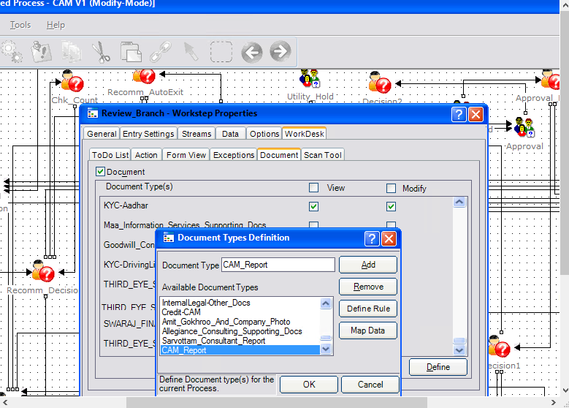
- Give the view / modify rights to this document.

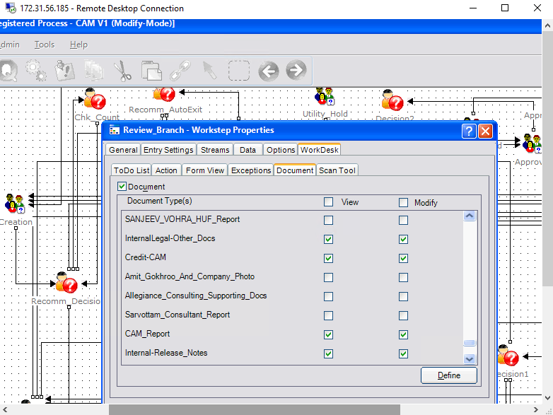
- Give Allow Addition rights to this document in scan tool
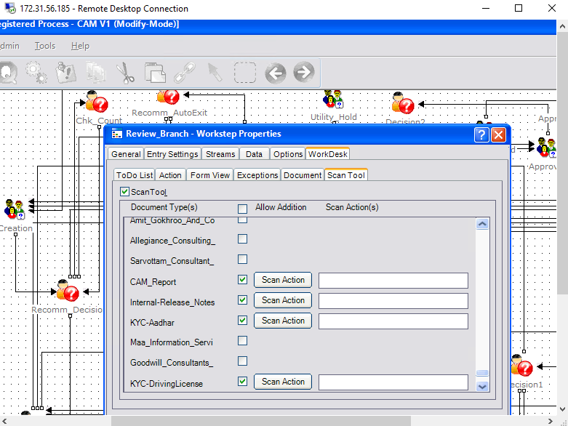
- Click Register Template
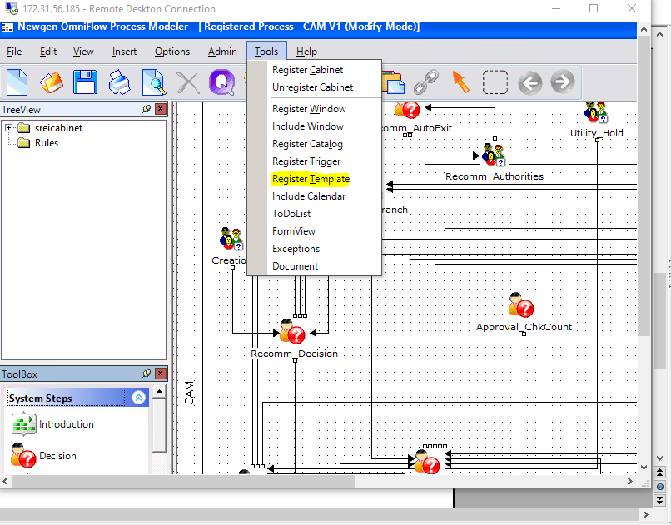

- Browse and attach the word template
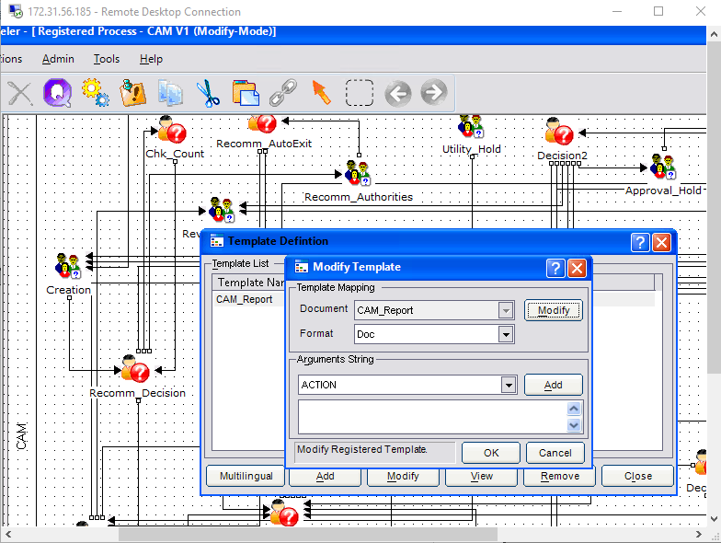
- Define the Generate Response Trigger.

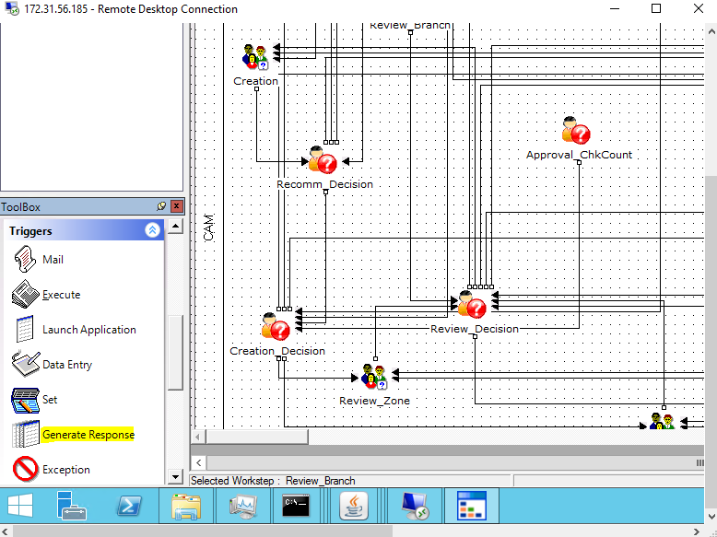
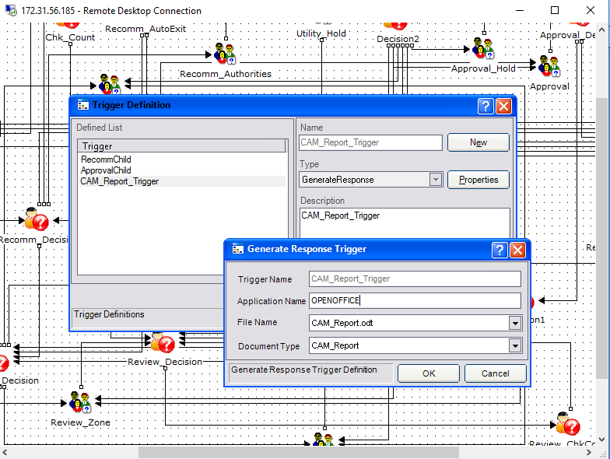
- After generate response trigger is defined add the action to required workstep.

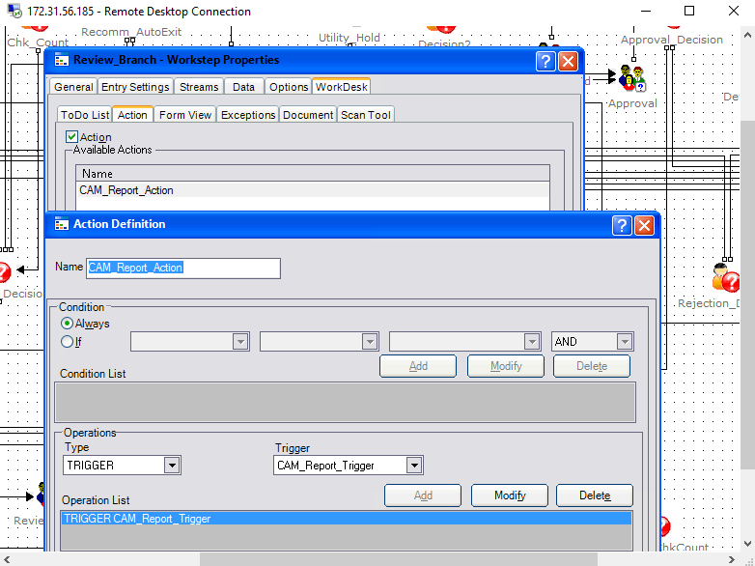

    - To populate data in word template through custom code. A CustomClass.class file is required at WEB-INF\classes\com\newgen\omniflow. And this file require some other class file given by product team. So paste the contents of WEB-INF folder inside webdesktop.war
(This WEB-INF folder is in 'Custom Generate Response Trigger' folder)

We have to use the method getGenerateResponseCustomTableList method to populate tabular fields and getGenerateResponseCustomData for linear fields.
I have created another class called CustomClassData in CustomClass.java file to seprated the logic to query and set the values in template. Therefore after compiling CustomClass.java you will get two class files. So, both of them need to be pasted at WEB-INF\classes\com\newgen\omniflow in webdesktop.war.
Steps to be followed for custom class.
Step 1: copy the WEB-INF in webdesktop.(You can found WEB-INF in 'Custom Generate Response Trigger') [This is one time step only]
Step 2: Compile The CustomClass.java to create class file.
a. To compile this class file copy the webdesktop.war to your local system. And extract it.
Now copy your java file to workdesktop\WEB-INF\classes\com\newgen\omniflow.
To compile open cmd->cd path to classes folder in my case it is 'C:\Users\bhanu.sharma\Desktop\workdesktop\WEB-INF\classes'
Now type javac com\newgen\omniflow\CustomClass.java, it will create two class files(as i have two classes in CustomClass.java)
Step 3: Copy the generated class file to 'WEB-INF\classes\com\newgen\omniflow' in webdesktop.war
Step 4: Copy the CustomClass.properties file at JBOSS's bin folder(This has DB Conection key value pair)
Note: For this all to work Open Office Should be installed on the server and to stop its service at server go to taskmanger-> details -> stop soffice.bin and soffice.exe
To start double click its openoffice listener LaunchOpenOfficeListener.bat.
If you are getting document is attached alert at webdesktop(browser) and nothing happens then stop and start as described above

